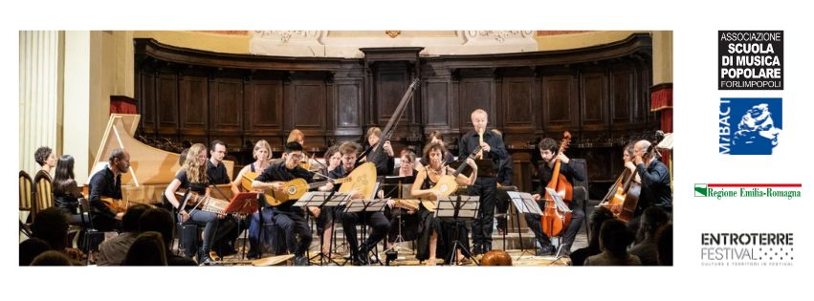

**EARLY MUSIC SUMMER MASTER CLASSES & NYCKELHARPA CAMP 5th to 8th August 2024**

**Application form**

CLASS: TEACHER:

Your name: Date of birth:

Permanent Address:

Zip Code: City/Country:

Phone: e-mail:

*(your personal data will be used only for the internal organization of the courses)*

**Do you wish to enroll as a regular participant or as an auditor?**

I am regularly enrolled at the Music Conservatories/Universities of Cesena-Rimini, Vienna, and/or Trossingen (yes or no):

I'm regularly enrolled at the normal classes of one of the teachers (yes or no):

The prices listed below are guaranteed only until February 28, 2025.   
After this date, the price will increase by €30. Along with your registration, we require a deposit of €100 to secure the hotel rooms. Please note that registration and the deposit payment do not guarantee participation, as each course will only take place if a minimum number of participants is reached. In the event that a course does not take place, the deposit will be refunded to the registered participants, unless they choose to join another offered course.

The bank account for making the deposit payment is:

**Name: SCUOLA DI MUSICA POPOLARE ASS.NE CULTURA**

**IBAN: IT82R0627067790CC0290176555**

**BIC: CRRAIT2RXXX**

**Please don't forget to specify the subject: EMM NC 2025**

The prices for the Summer Master Classes 2025:

**Master Classes:**

• Regular participants: € 220 / Listeners: € 100

• Students regularly enrolled at the Universities of Bologna, Cesena-Rimini, Vienna or Trossingen and/or regularly enrolled at the normal classes of the teachers:

€ 190 / Listeners: € 100

**Nyckelharpa Camp:**

• Participants of Annette Osann: € 190 / Listeners: 100 €

**If you wish to stay in an affiliated facility (hotel), please specify the preferred type of accommodation to book it:**

* HOTEL B&B (4 DAYS) SINGLE ROOM € 240,00/pp
* HOTEL HALF-BOARD (4 DAYS) SINGLE ROOM € 280,00/pp
* HOTEL FULL-BOARD (4 DAYS) SINGLE ROOM € 310,00/pp
* HOTEL B&B (4 DAYS) DOUBLE ROOM € 200,00/pp
* HOTEL HALF-BOARD (4 DAYS) DOUBLE ROOM € 240,00/pp
* HOTEL FULL-BOARD (4 DAYS) DOUBLE ROOM € 270,00/pp

**Meals details**

* Vegetarian
* Vegan
* Specify any food intolerances. __________________

**date of arrival (check in): date of departure (check out):**

Date:_________ Signature__________________